Andree Salvo
Southern New Hampshire University
CYB 400-13022
Instructor: Robert Chubbuck
8-2 Cyber Playbook Submission

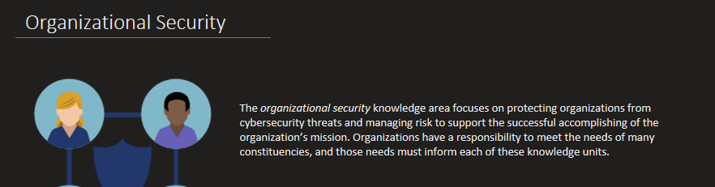
I chose the Organizational Security section as the most valuable to me because it highlights the importance of protecting an organization from cybersecurity threats and managing risk to ensure its mission is accomplished successfully. I find this important because it highlights that cybersecurity encompasses not only technology, but also responsibility, communication, and leadership at all organizational levels. This form of knowledge will guide me in my future cybersecurity career by reminding me that maintaining security requires a proactive approach to risk management and a strong commitment to meeting the needs of both the organization and its stakeholders.

